PACIFIC NORTHWEST FJORD PROMOTIONAL GROUP
SPRING MEETING MINUTES
VIA CONFERENCE CALL THROUGH Freeconferencecall.com
February 29, 2020 6:00PM
Dial-in number: 425-436-6314
Access code: 154066

Meeting called to order at 6:07pm
Present on the call: Sherrie Dayton, Shirely Anderson, Linda Stevenson, Bonnie Morris, Barb & Fred Lynch, Eric Watness

Approval or corrections of last meeting minutes:
Minutes from the July meeting have been posted on the website since August, 2019. Barb, proposed accepting the minutes as posted, and waiving the reading, second by Shirely. Vote taken, all approved. Linda presented highlights of the minutes by way of reminder:
- The equipment trailer is inadequate in size to house all our equipment so we need to find something bigger and inexpensive. Also still need a place in Sandpoint to store it.
- Eric explained some of the changes to the evaluation process
- None of us have done much work on the NFHR project which was to put together lists of potential owners who we could contact directly to drum up interest in joining the PNFPG.

REPORT OF OFFICERS
- Chairperson-Sherrie Dayton: nothing to report

- Vice Chair: Shirley Anderson: nothing to report

- Treasurer-Solveig Pedersen: Solveig was not able to join the conference call but sent a P&L to Linda to present to the members. She has updated the account on the club computer in quickbooks but some changes and additions to the chart of accounts is necessary to give us a better picture of show expenses and things like that. The current bank balance is $9027.31 with $362.01 in membership fees in the process of being transferred from Paypal. So we have the P&L but we don’t have a confirmed breakdown of the expenses for the show. Roughly it looks like we brought in $7131 from the show and spent $4977.74 for facilities and the judge. There were additional costs for more ribbons but those costs were not broken down for identification in this report.
Discussion: web hosting too high
Need the breakdown on the items in the report. Linda will get the info from Solveig and include it in the minutes and also send it to the board for approval as it cannot be approved at this time with the limited info. Shirley suggested putting report under advisement. All approved

REVISED P&L CREATED FROM REPORTS SENT BY SOLVEIG IS SHOWN BELOW AND INCLUDES A BREAKDOWN OF INDIVIDUAL CATEGORIES WHERE THEY COULD BE DETERMINED

PACIFIC NORTHWEST FJORD PROMOTIONAL GROUP
PROFIT & LOSS detail
January through December 2019

Ordinary Income/Expense
Income
Membership (including paypal trnsfrs) 638.92
Promotions (Betsy % to PNFPG) 262.00
Show Income 7,131.00
(in this report, no breakdown for camping, stalls,
Meals, sponsorships, etc. is available)
Total Income 8,031.92

Expense
Business operations
Computer & supplies
Newsletter & fliers 284.43
Postage & mailing 35.30
Service charges 4.00
Supplies (includes $11.55 credit) 127.82
Web hosting 239.85
Other
Design Print (banner) 126.51
Canadian Exchange 174.49
Total Other Expenses 301.00
Total Business operations expenses 992.40
Insurance 693.00
Show Expenses
Computer equipment
Equipment
Facilities Expense (stalls,camping not sep) 2,890.00
Group Meals expense 341.65
Judge Expenses
Daily Judging Fee 1,156.20
(includes Terri’s fee $700, car rental/fuel 206.20, Kathi fee $250)
Hotel 286.17
Meals 37.50
Airfare 217.99
Total Judge Expenses 1,697.86
Porta Potties 312.70
Ribbons & Prizes (most pd in 2018)
Stall Cleaning 100.00
Supplies 196.91
(reimb to Linda –see attachment A)
Miscellaneous (see attachment B) (62.20)
Total Show Expenses 5,476.92

Total Expenses 7,162.32

Net Ordinary Income 869.60

Original P&L from Solveig

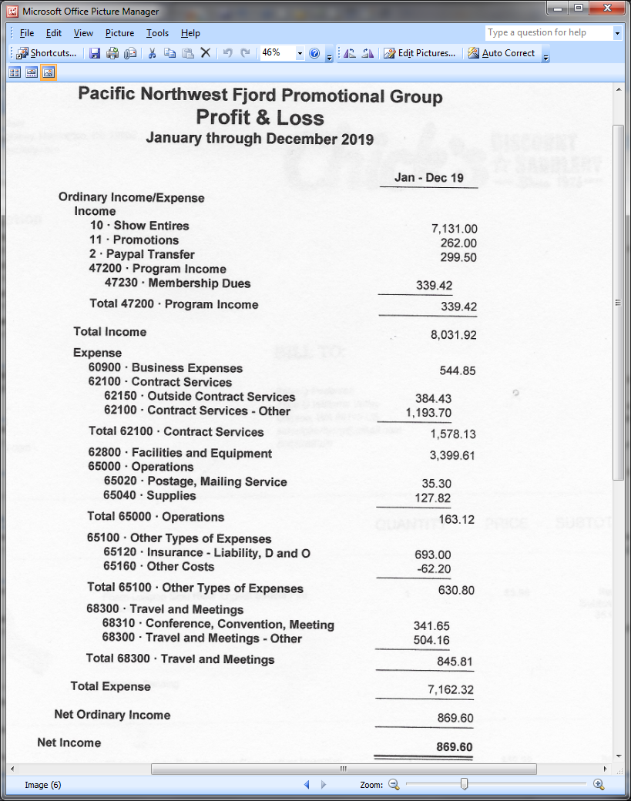

- Secretary–Linda Stevenson:
ACTIVE MEMBERSHIP – 48
EXPIRED MEMBERSHIP – 27 (11 expired in 2018, 16 expired in 2019), reminders emailed 2/27/20
Decals have been mailed to everyone whose membership was good through Dec 31, 2020 and to those who have joined or renewed in January or February.
Overall our membership is dropping.
Bonnie asked if the FaceBook page should be open to PNFPG club members only. Over 300 people on our FB page. Should let the public see some things but posting, etc only for members. Discussion as to the practicality of doing that since FB host and secretary would need to work together . Barb did not think we should limit access and thinks people are more likely to join the club if they can see the chats. Linda suggested bringing it up at the July meeting. Bonnie says there are ways to regulate FB .

- Newsletter-Bonnie Morris: have only received one article. Reminded she has until fall to get the newsletter out and only need fliers in between time.
Discussion regarding the cost of mailing in envelope vs the clear sleeves. Possibly more expensive in the sleeves. Eric suggested contacting Nancy or Jeannie with NFHR to find out how they mail their Herald. Bonnie requested a show personnel update to put in the flier. Linda will send that to her.

- Report of show committee: Linda Stevenson
We are in good shape for the show. Judges will be Karen Maas and Kathi Wardenaar. (Sherrie still needs to send the contract to Karen). The dates have been secured with the fairgrounds. Our food vendor, The Wurst Man in Town, will be returning as will our announcer, Karl Froelich and our ring steward Laurie Merlo. Our secretary will be Michelle Noonan and Vance will again be hauling the manure. We still need a volunteer for arena boss and whipper-in and we are still looking for some ideas for entertainment during the lunch hour or for fillers. We will NOT be providing the option for stall stripping this year unless someone reliable who will already be at the show wants to step up and do that. The classes still need to be updated. We will mostly go with the same schedule because it works really well but we need to do some new games and decide what the group would like to do on Sunday. We do have the services of our judge for Sunday so we need to have classes that will take advantage of that. The working equitation style derby was fun and well attended last year but didn’t work well for the drivers because the obstacles were too tight. It might be possible to construct it so that the drivers just do a cones course. We are open to ideas.

Bonnie asked about green horse driving class option and rules. Cannot cross over to open classes.

OLD BUSINESS
- Trailer: need different trailer. Despite organization, travel moves everything around. Even if we keep the trailer it needs some shelves, netting, racks, etc. We really need a bigger trailer that can also haul the logs and barrels but we don’t have funds now. Sherrie suggested maybe talking to a local trailer company to see about shelving, etc. Also the trailer has to be able to handle the extra weight and we want to be under a certain weight so we don’t have to pull over for inspection.
  - Greg let us know that the tires need to be replaced this year and the spare also because it has no tread. Sherrie will get the size of tires and call for prices.

- Regarding increasing membership – at the spring meeting 2019 Bonnie suggested accessing pedigree search list by state from NFHR. Over 1000 fjords so quite a few owners. We should send a mailing to them as to the existence of the club and why they need to support the fjord club and also a membership application. Maybe say that gift memberships are available. Bonnie is thinking of creating the letter and mailing to the officers. For researching – get 4 people, each to research a state. Can click to alphabetize by owner. Linda-Idaho, Mandy&Michelle-Montana, Solveig- Oregon, Sherrie-Washington. Will try to have this idea put together and ready to go by middle of May. Everyone will email their state list to Linda and she and Sherrie will do the printing, stuffing, and mailing.

  - Bonnie created a draft of the letter that was to be sent out. It needed some corrections but I have not received a final copy. I don’t think anyone has completed their list though some of us did some initial research. I created a spreadsheet to record the info for the Idaho people and started adding contact info but I have not completed it.
  - Sherrie asked for help with Washington. Barb offered to help her and she will contact Sherrie later.

NEW BUSINESS

No new business
Barb motioned to adjourn the meeting, Shirley second. Meeting adjourned 7:28pm

POST SCRIPT ADDED FOR INFORMATIONAL PURPOSES as of 5/12/20:
A couple of weeks after this meeting the country went on unprecedented “stay at home” recommendations or requirements in most states due to the COVID-19 pandemic crisis. This necessitated cancelling of events that were scheduled from March through July and possibly beyond, closing of most businesses, etc. No one has been able to meet in person with others outside of their household until mid May or later.

